Florida Gulf Coast University | SCM3005: Supply Chain Management | Laura Birou | February 27, 2022

Zachary Busby
Justin Mattia
Jonathan Orth
Iris Serrano
M&M SPC Assignment
2022
Table of Contents
Section I. Introduction 2
Section II. History of Mars Inc. 5
Section III. Role of Quality Control, Quality Management 7
Section IV. SPC Analysis 10
Data Collection and SPC Tools 10
X-Bar and R Chart Analysis 12
P Chart Analysis 15
Section V. Conclusion 20
Bibliography 21

Section I. Introduction
Supply chain management. What is it? As defined by Oracle, supply chain management (SCM) is “management of the flow of goods, data, and finances related to a product or service, from the procurement of raw materials to the delivery of the product at its final destination” (Oracle, n.d.). In simpler terms, the supply chain can be defined as a source of connection for customers and companies. Product management, supply chain planning, logistics, and order management are just some of the basic activities that come with SCM. These activities can even span to those of global trade. The entities in the supply chain can include producers, vendors, warehouses, retailers, distribution centers, and transportation companies. According to the Council of Supply Chain Management Professionals, “it is well known that supply chain management is an integral part of most businesses and is essential to company success and customer satisfaction” (Council of Supply Chain Management Professionals, 2022). Supply chain managers deal with problems, find ways to move past disruptions, and decipher how to move along products to customers in the most efficient way possible. SCM plays a huge role in society, for experts are always trying to find ways to improve and diagnose any emergencies that may occur. Although supply chain has been based upon seeking efficiency and reducing costs, the increasing size of the market have made it difficult for that to be set in stone. It is a continuous evolving chain, and its effectiveness relies on the agility to react to certain occurrences. The chain has changed completely with the welcoming of many new choices to buy products. Consumers now having the options of buying in store, online, or other ways have made it more crucial for the supply chain to be agile and deliver to any needs. This report will be based on the company, Mars Inc., and the production of their hit product M&M’s. The purpose of this report will be to analyze Mars and the measure they take every day to ensure each product is manufactured with the best quality for the end customer’s satisfaction. It will include a data analysis to look into any circumstances of defectiveness among their M&M product and what variables may be contributing to this. Application of quality control methods alongside Six Sigma principles is necessary to highlight an extent of product quality in the assembly line. For our group to gain a better understanding on the quality control of Mars’ hit product we also needed to learn about the people who played a big role in the existence of this quality. According to W. Edwards Deming, “good quality means a predictable degree of uniformity and dependability with a quality standard suited to the customer” (Chandrupatla, T. R., 2019). Quality in a supply chain always has room to improve. This can occur by focusing on customer value and producing the best product. Reducing things such as cost will also lead to a decrease in customer dissatisfaction. We took some time to research the man who was responsible for statistical quality control. This was none other than Walter A Shewhart. Supply Chain Management Review survey techniques including “innovation in contracting management, providers optimization, and supplier financial stability” (Trowbridge, M., 2017) that help discover the true quality of M&M’s. Our studies used the weight as the variable data to contrast both x bar and r bar charts. We also used color as attribute data to construct the p charts in our report. The creation of these charts made it attainable to find common cause and specials cause variation. Six Sigma Daily states that, “common cause variation is where no one, or combination of factors is unduly affected the process variation. Special cause variation is when one or more factors are affecting the process variation in a non-random way” (Staff, 6S. D., 2018). The SPC analysis displayed that Mars seems to have handled in terms of the color ratios present in each bag of M&M’s. We concluded from the analysis that Mars is doing great by staying within its own limits when it comes to filling each individual bag of M&M’s. Our report will further prove any defections with the M&M’s product. Our conclusion will end talking about any solutions and further steps that Mars should take in order to give out the best quality in their products.

Section II. History of Mars Inc.
Mars was founded in 1911 by Frank C Mars, who started by making and selling candy from his kitchen is Tacoma, Washington. He relocated to Minneapolis in 1920 and continued to expand production and develop new candies like the Milky Way and Snickers Bar (Mars, 2022). In 1940, Forrest E. Mars Sr. established M&M’s Limited and released the first M&M’s chocolate candies. As detailed by the M&M’s franchise, these candies were first developed for soldiers during World War II, but quickly became popular with the public (M&Ms, 2022). The popularity of the candy skyrocketed, and as of 2017 M&Ms were the top ranked chocolate candy in the United States (PSU, 2018).
Currently, over 400 million M&Ms are produced each day worldwide (U Texas, 2021). Around 50% of all M&Ms sold in the US are made at the Mars Chocolate North America campus in New Jersey (Smith, 2016). This facility is the standard which all M&M’s production facilities are expected to follow. This facility follows the process of mixing and tempering the chocolate to a precise temperature needed for M&Ms to reach their desired shape. Once they cool, the chocolate pieces are sent to a processor where the coloring drips onto the pieces and hardens (Smith, 2016). After this, the finished M&Ms are conveyed to be sorted into their appropriate color ratio per bag, 1/8 of red, yellow, green, and brown, and 1/4 blue and orange (Wicklin, 2017).
With M&Ms being a chocolate product, Mars has faced supply chain issues typical of the cocoa industry. These concerns mainly surround the ethics of sourcing and the environmental impacts of chocolate making. These concerns continue to grow with the US chocolate market alone reaching $19 billion in 2021 (Wunsch, 2021).
The cocoa supply chain is commonly associated with human rights violations in the forms of child labor and farmer exploitation (Ceres, 2021). Mars has addressed this through their Cocoa for Generations report, where they acknowledge the human rights atrocities of the industry and describe the framework that they are using to combat it. They detail their mission to closely monitor all work environments, provide quality education to the children in cocoa growing communities, financially support the farming families, and improve the income and standard of living in farming communities across West Africa (Mars Wrigley, 2022).
Cocoa production is highly correlated with deforestation and damage to soil health. Roughly 90% of West Africa’s primary forests have been destroyed, with roughly 15% being directly tied to cocoa production (Ceres, 2021). Mars is highly involved in eliminating deforestation and soil erosion from the supply chain. They partake in the distribution of multi-purpose trees to help revive the soil on cocoa farms and are actively transitioning to a zero-emission supply chain. These activities are also transparent to consumers, with consistent updates about their supply chain discourse, and the goal of making their entire supply chain zero emissions by 2050 (Nunes, 2020).
Mars prides itself on its accountability and transparency with consumers in relation to the supply chain. As of 2019, Mars claims they can trace 95% of their cocoa production to its origin country, and 25% to the individual farm. (Mars, 2020). They also have made efforts to reduce the number of suppliers they work with. Mars has cut the number of mills it works with from 1,500 to below 100 since 2020 and aims to bring this number down to 50 (Hart, 2020). They also publish fully updated versions of all their quality control standards, including the standards involved in packaging, warehouse conditions, and production areas (Mars, 2021).

Section III. Role of Quality Control, Quality Management
Quality control deals with the process of detecting faulty products and defects before launching out as well as preventing bad services. As a business seeking to maximize profit, maximizing the quality of the product or service being sold is one of the most important goals to meet. With quality control the standard of a product or service is checked to make sure it meets and exceeds consumer expectations. Exceeding customer expectations is one of the most prominent goals that every business strives to meet but, it is not the only reason why quality control is important. According to an article on the small business website Chron, “Quality control processes help your business avoid situations that cause harm to customers and lead to expensive liability claims and lawsuits” (Gartenstein 2019, pg. 1). If a product is launched out either prematurely or with mistakes it heightens the chances of the business being brought down. So, to help deal with and ensure quality control comes quality management which oversees the process of quality control. Not only does quality management deal with checking the final product, but they also deal with all the steps having to do with creating a product or providing a service. Quality management deals with Quality Planning, Quality Assurance, Quality Control, and Quality Improvement. Quality Planning is setting a goal and determining how to meet that goal in the manufacturing process. Quality Assurance is the process of determining whether or not the product or service meets the requirements that were set in the planning step. The last step is Quality Improvement which utilizes all that is written above to ensure the progress of quality gets better. To go further explain, the article Managing Service Quality says, “Quality improvement is used as a collective expression for quality assurance, quality management and quality control” (Edvarson 1998, pg. 142). Furthermore, Quality management focuses on not only product and service quality, but also on the means to achieve it. Quality is one of the five principles that the Mars company focuses on. According to their website, “Quality is the basis of the brand loyalty and consumer trust that has made Mars the company it is today.” (Reed 2007) The Mars Company takes pride in delivering quality products and whilst doing so, they also reduce the amount of waste their company accounts for. There are many things to consider on how Mars is able to deliver quality. Now, to ensure good quality, and be able to analyze quality control, I introduce Statistical Process Control, which applies statistical methods to monitor and control a process, to ensure that the process operates efficiently. There are various tools that can be used to do this which include but are not limited to: control chart, check sheets, histograms, etc. The most popular of these is the control chart. “A control chart helps one record data and lets you see when an unusual event, such as a very high or low observation compared with "typical" process performance, occurs” (Bajaria 1986, pg. 76). To further explain, a control chart makes it easy to catch errors early on in production. The Mars company has applied this specifically into their M&M candies, to ensure quality. Because the Mars company has integrated various forms of process controlling, as a result they make a significant impact on sustainability. Mars inc. is becoming more and more environmentally friendly. They help the planet by capturing rainwater to reduce their water use during production, they also have invested in wind farms, “The Mesquite Creek wind farm, its 118 turbines produce 200 megawatts (MW) of energy, equal to 100 percent of the company’s needs in the U.S. or enough to produce 13 billion Snickers bars a year” (Cheeseman 2016). By the Mars company investing in a wind farm, they have saved a significant amount of energy waste, leaving a more sustainable company for the future. Another way the Mars Company has impacted sustainability, they have helped people by making sure they do business with high human rights. Unlike other companies who outsource to different countries for cheaper labor and supplies, the Mars company has done the complete opposite. Matthias Berninger, the Vice President of Public Affairs for Mars stated, “We need to make sure we buy the best, not just the cheapest,” (Berninger 2017) this creates a sustainable future by not contributing to the ethical gray space that is outsourcing. To make a way back to quality control, everything comes together with the importance of quality control is a consumer bases, but also in a sustainability basis. The tools that we will use to conduct this analysis are the X-bar and R-Charts in which will be further explained in this next section.

Section IV. SPC Analysis

Data Collection and SPC Tools
For any analysis to begin, data needs to be collected. For this, students were given bags of Mars Chocolate M&M’s, a sample size of sixty bags, and were then instructed to count how many M&Ms were in the bag and how many of each color was present. The raw data collected is shown here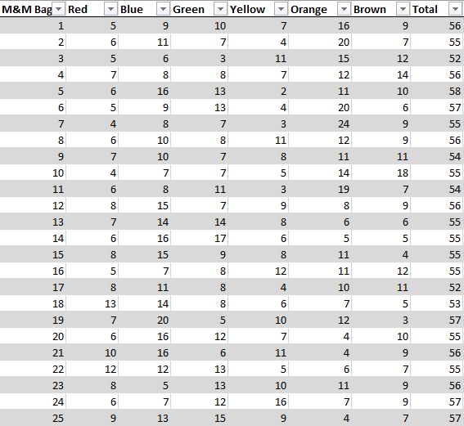
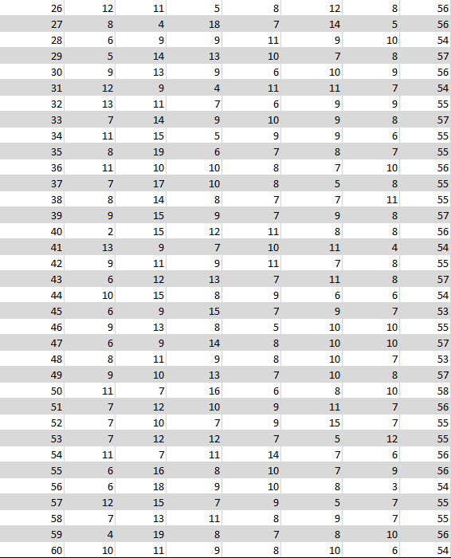
(M&M Data)
Next, the analysis had to be conducted. Though getting there is still a few steps away. Before that, we need to decide what tools we will use to properly get the results we need. Consulting the resources we had, it was concluded that control charts, such as X-Bar, R Chart, and P Charts, will be used for our analysis. (Control Chart, n.d.)

X-Bar and R Chart Analysis
With the raw data in our hands and the proper tools ready, it was time to conduct the first part of our analysis. Before you can make an X-Bar and R Chart, you need to organize the data properly into sample sizes. We put the sixty M&M bags into fifteen samples with four bags in each sample. The average of each sample group was calculated, along with the range. With the averages and ranges known, we could then multiply them by 0.884 grams. This table was made to showcase the information so far: 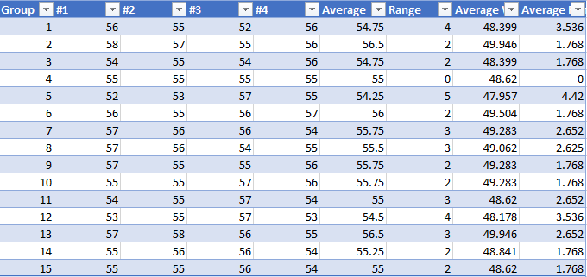
The formulas for X-Bar and R-Charts are as follows: 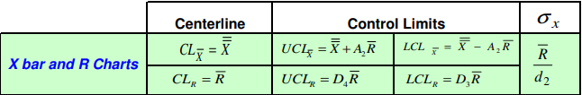
(Control Chart Formula)
The list of variables and their values:
- $\overset{̿}{X}=48.929$
- $\overline{R}=2.297$
- $A_{2}=0.729$
- $D_{3}=0$
- $D_{4}=2.282$
The formulas used with the values of the variables in place:
- ${CL}_{\overline{X}}=48.929$
- ${UCL}_{\overline{X}}=48.929+0.729*2.297=50.604$
- ${LCL}_{\overline{X}}=48.929-0.729*2.297=47.255$
- ${CL}_{R}=2.297$
- ${UCL}_{R}=2.282*2.297=5.241$
- ${LCL}_{R}=0*2.297=0$

Knowing the Control Limit, Upper Control Limit, and Lower Control Limit for the X-Bar and R Chart is the last piece of the puzzle in constructing our graphs. All the work now leads to this:
What we can conclude from this analysis is that Mars Chocolate is doing great by staying within its own limits when it comes to filling each individual bag of M&M’s. Each of the sample groups stays within the Upper and Lower Limits and hovers around the Center Limit. The only thing of note here is Group #4. Each of the four bags in that group had fifty-five M&M’s, meaning the range in that group would be zero.

P Chart Analysis
Now it is time to analyze the assortment of colors in each of the individual bags of M&M’s. M&M’s have six different main colors: Red, Blue, Green, Yellow, Orange, and Brown. When asked about the distribution of these colors, the Mars Chocolate company responded with this information:
M&M Color | Color
Red | 13%
Blue | 24%
Green | 16%
Yellow | 14%
Orange | 20%
Brown | 13%
(Chocolate, 2013)
These are the assumed to be observed percentages. If you were to randomly open a bag of M&M’s, this would be on average what you would expect to receive. To begin creating the P Charts for each color, we need to define new variables and plug them into new equations.

The new set of variables and their values are:
- $n=3321$
- $p=0.130, 0.240, 0.160, 0.140, 0.200, and 0.130$
- $\overline{n}=55.350$
- $\overline{p}=0.140, 0.214, 0.174, 0.145, 0.178, and 0.148$
The new set of UCL and LCL formulas along with a filled-out example:
- $UCLp=\overline{p}+3\sqrt{\frac{\overline{p}(1-\overline{p})}{\overline{n}}}$ $0.140+3\sqrt{\frac{0.140(1-0.140)}{55.350}}$
- $LCLp=\overline{p}-3\sqrt{\frac{\overline{p}(1-\overline{p})}{\overline{n}}}$ $0.140-3\sqrt{\frac{0.140(1-0.140)}{55.350}}$ (McNeese, 2005)
Using these UCL and LCL formulas, and the CL Mars Chocolate provided, we can now put together each color’s P Chart:

What we can gather from each P Chart, is that for most of the sixty bags examined, almost all of them nicely fit in-between the Upper and Lower Limits. Red M&Ms mostly seem to trend high above the Center Limit. They get close to the Upper Limit but never pass it. On the Blue P Chart, it seems to be the opposite, mostly below the Center Limit. Though some bags edge near the Upper Limit, like with Bag #19 having 35% Blue M&M’s. Green M&Ms followed the same general trend as Red, being mostly above the Center Limit. Bags #14 and #27 barely reached the Upper Limit having 31% and 32% Green M&Ms respectively. Yellow had the same results, Bag #24 had 28% Yellow M&M’s. Other than that, one outlier, it stayed right around the Center Limit. The Orange color was the first to pass the Upper Limit, and it did so four times. Bags #2, #6, #7, and #11 were all above. Brown only had one bag reach above the Upper Limit, that being Bag #10. As it would seem, only five out of the sixty bags examined went past the upper threshold. That is only 8.3% of bags. In conclusion, Mars Chocolate seems to have it handled in terms of the color ratios present in a bag of M&M’s.

Section V. Conclusion
After finalizing and collecting data based on the Mars’ company M&M product, we can conclude that the quality control of this product is dedicated towards customers happiness. It has been undoubtedly seen that the consistency of the M&M product is clear after our report. The frequency distribution of M&M’s aligns close to perfectly with the statistical ranges. The data showed that the distribution was completely normal. The data we discovered showed that Mars handled their ratios of color and quantity in each bag. According to CQI, “Quality assurance is an essential part of any supply chain, and has become a top priority for both buyers and sellers in the food and beverage industry. When prioritized, a focus on quality reduces operational costs and business losses in the form of rejected goods, delayed shipments, storage fees, container charges, and more” (CQI | IRCA. 2021). Mars company has made sure that they use these tactics to provide good service to their customers, and to reduce dissatisfaction among their buyers. The SPC analysis displayed the numbers that showed consistency among colors of the M&Ms. Covid-19 can pose supply chain risk to companies like Mars. They have faced a great deal of uncertainty when Covid-19 threatened their ability keep workers busy in factories. According to Oxford academic, “A major concern shared by all food companies is preserving the employee’s health and the provision of sufficient workforce due to those who do not want to work because of sickness or coronavirus fear. It is very important to protect and maintain the health of people working in the food supply chain during this time of crisis. However, keeping the distribution chain alive by the supply management strategies is also important to meet the consumer demands” (Aday, S., & Aday, M. S. 2020). Consumers usually do not consider how food on the table is manufactured. Mars company can use solutions as mechanical machines to keep packing their products. The M&M product is efficiently produced and made with machinery as opposed to people packing each item. Mars has made it clear that have taken significant steps to protect everyone including their employees. Mars company stated, “Our approach to COVID-19 has been, and will continue to be, putting the safety and wellbeing of our Associates first, doing our part to prevent the spread of the virus” (Will. Smith. 2021). This displays the direction they are headed to making their supply chain safer and more efficient for all. Mars has also significantly impacted the community through their work. They have focused on getting products to people in need and making a difference through donations. Mars says in response to Covid-19, “In the broader community, we’ve been focusing on making a difference through our collective donations of cash and products – totaling more than $42 million – and through acts of generosity and kindness demonstrated by Associates. Our Five Principles continues to guide our actions today to set us up for the world we want tomorrow” (Will. Smith. 2021). They are committed to the process of progressing towards a bigger and better goal. This contributes to their success in the supply chain every day. Mars company is a staple of good quality and they aren’t satisfied. O’Reilly states, “Mars quality management process is maintained at the leading edge of quality management practices by benchmarking against the highest quality and food safety standards and best practices throughout the food industry” (Wiley, n.d.). We see this every day in their supply chain and in our report.

Bibliography
Aday, S., & Aday, M. S. (2020, August 24). Impact of covid-19 on the Food Supply Chain. OUP Academic. Retrieved February 27, 2022, from https://academic.oup.com/fqs/article/4/4/167/5896496
Agardiner. (2022, February 11). Mars builds on Cocoa Supply Chain Transparency: Mars, incorporated. Global Petcare, Food, Mars Wrigley and Edge Brands. Retrieved February 24, 2022, from https://www.mars.com/news-and-stories/articles/cocoa-supply-chain-transparency
Ceres. (2020, October 15). Cocoa- Engage the Chain. Engage the Chain. Retrieved February 24, 2022, from https://engagethechain.org/cocoa#:~:text=The%20most%20salient%20issues%20in,of%20droughts%2C%20pests%20and%20disease.
Chandrupatla, T. R. (2019). Quality Concepts. Cambridge University Press. Retrieved February 26, 2022, from https://assets.cambridge.org/97805215/15221/excerpt/9780521515221_excerpt.pdf
Cheeseman, G. M. (n.d.). How Mars is becomming More Environmentally Friendly. Justmeans. Retrieved February 24, 2022, from http://www.justmeans.com/blogs/how-mars-is-becoming-more-environmentally-friendly
Chocolate, M. (2013, March 27). M&M Color Ratio. (vaughnfpasha@gmail.com, Interviewer)
Control Chart. (n.d.). Retrieved from ASQ: https://asq.org/quality-resources/control-chart
(n.d.). Control Chart Formulas. Institute of Quality and Reliability.
Cosgrove, E. (2018, September 20). Mars will invest $1B to fix 'broken' cocoa supply chain. Supply Chain Dive. Retrieved February 24, 2022, from https://www.supplychaindive.com/news/mars-broken-cocoa-supply-chain/532843/
Council of Supply Chain Management Professionals. (2022). The Importance of Supply Chain Management. CSCMP. Retrieved February 26, 2022, from https://cscmp.org/CSCMP/Develop/Starting_Your_Career/Importance_of_Supply_Chain_Management.aspx
CQI | IRCA. (2021, October 7). Quality assurance in the supply chain. Retrieved February 27, 2022, from https://www.quality.org/knowledge/quality-assurance-supply-chain
Edvardsson, B. (1998, April 1). Service Quality Improvement. Managing Service Quality: An International Journal. Retrieved February 25, 2022, from https://www.emerald.com/insight/content/doi/10.1108/09604529810206972/full/html
Gartenstein, D. (2019, March 6). Why is it important for businesses to practice quality control? Small Business - Chron.com. Retrieved February 24, 2022, from https://smallbusiness.chron.com/important-businesses-practice-quality-control-69340.html
Hart, C. (2020, October 7). Why Mars is dropping 1,450 suppliers. Supply Management. Retrieved February 24, 2022, from https://www.cips.org/supply-management/news/2020/october/why-mars-is-dropping-1450-suppliers/
Henderson, G. R. (2011). Six Sigma Quality Improvement with Minitab. Hoboken: John Wiley & Sons, Ltd.
M & M Data (2021)
M&M's. (2022). M&M's history. M&M's. Retrieved February 24, 2022, from https://www.mms.com/history

Mars North America. (2021). Quality Control Standards Exhibit B. Mars food services. Retrieved February 24, 2022, from https://www.marsfoodservices.com/docs/default-source/default-document-library/logo-access-terms-conditions.pdf?sfvrsn=2
Mars. (2021). Mars Food 2020 purpose in Action report - lighthouse.mars.com. Mars.com. Retrieved February 24, 2022, from https://lighthouse.mars.com/adaptivemedia/rendition/id_fa75bd3442dce9c8966fd41e53603dace2feaa00/name_out/Food%20Purpose%20in%20Action%20Report%202020%20FINAL.pdf
Mars. (2022). Our history: Mars, incorporated. Global Petcare, Food, Mars Wrigley and Edge Brands. Retrieved February 24, 2022, from https://www.mars.com/about/history
McNeese, D. B. (2005, July). p Control Charts. Retrieved from SPC for Excel: https://www.spcforexcel.com/knowledge/attribute-control-charts/p-control-charts
Nunes, K. (2021, October 5). Mars looks to eliminate emissions throughout supply chain. Bake Magazine RSS. Retrieved February 24, 2022, from https://www.bakemag.com/articles/15255-mars-looks-to-eliminate-emissions-throughout-supply-chain
Oracle. (n.d.). What is supply chain management? (SCM). Oracle. Retrieved February 24, 2022, from https://www.oracle.com/scm/what-is-supply-chain-management/
PSU. (2018, October 20). (M)urrie & (M)ars. History of candy. Retrieved February 24, 2022, from https://sites.psu.edu/tota137/2018/10/20/m-urrie-m-ars/
Quality and Food Safety: Mars, incorporated. Global Petcare, Food, Mars Wrigley and Edge Brands. (n.d.). Retrieved February 25, 2022, from https://aus.mars.com/about/policies-and-practices/quality-and-food-safety
ratih_n. (n.d.). Quality commitment: Mars, incorporated. Quality Commitment | Mars, Incorporated. Retrieved February 25, 2022, from https://www.mars.com/about/policies-and-practices/quality-commitment
Smith, J. (2016, July 21). Here's an inside look at how M&M's are made. Business Insider . Retrieved February 24, 2022, from https://www.businessinsider.com.au/mars-mms-tour-2016-10
Staff, 6S. D. (2018, June 4). Common-cause vs. special-cause. Six Sigma Daily. Retrieved February 26, 2022, from https://www.sixsigmadaily.com/common-cause-vs-special-cause/
Trowbridge, M. (2017, November 8). Five techniques to manage supply chain risk. Supply Chain Management Review. Retrieved February 26, 2022, from https://www.scmr.com/article/five_techniques_to_manage_supply_chain_risk
U Texas. (2021). How many M&M's® are consumed and produced each day? what ... Retrieved February 24, 2022, from https://la.utexas.edu/users/jmciver/350K/NOTES/M&Ms_FAQ.pdf
What is Statistical Process Control? ASQ. (n.d.). Retrieved February 25, 2022, from https://asq.org/quality-resources/statistical-process-control
Wicklin, R. (2017, February 20). The distribution of colors for plain M&M candies. The DO Loop. Retrieved February 24, 2022, from https://blogs.sas.com/content/iml/2017/02/20/proportion-of-colors-mandms.html#:~:text=HKP%3A%20The%20Hackettstown%2C%20NJ%2C,0.25%2C%20and%20Brown%3D0.125.
Wiley. (n.d.). Operations management: Creating value along the supply chain, 7th edition. O'Reilly Online Learning. Retrieved February 27, 2022, from https://www.oreilly.com/library/view/operations-management-creating/9780470525906/ch03.html
Will.smith. (2021, January 6). Our global covid-19 response: Mars, incorporated. Global Petcare, Food, Mars Wrigley and Edge Brands. Retrieved February 27, 2022, from https://www.mars.com/covid-19
Wunsch, N.-G. (2020, November 25). U.S. Chocolate Market Size 2016-2025. Statista. Retrieved February 24, 2022, from https://www.statista.com/statistics/1118232/us-chocolate-market-size/

$A_{2},D_{3}, and D_{4} were all found from Factors for Control Charts$$CITATION GRo11 \backslash l 1033 (Henderson, 2011)$

